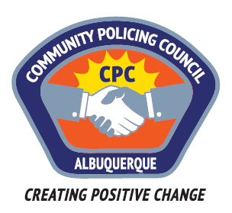
Southwest Area Command Community Policing Council
AGENDA
Wednesday, March 8, 2017
6:00pm – 7:30pm
Patrick J. Baca Library; 8081 Central Ave NW

1. Call to order – Michael Zocholl (interim Chair)
2. Roll call & Introductions
3. Approval of agenda
4. Approval of minutes
5. Guest speaker Celina Espinoza; APD Director of Communications- Progress Update and new goals regarding the City and Department’s Court Approved Settlement Agreement

6. Public comments/questions regarding guest speaker
7. Michael Zocholl: Update on CPC Summit hosted by CPOA
8. Group discussion on Future recommendations & guest speakers
9. Adjournment

Next meeting: Wednesday, April 12th 6-7:30PM

